SOLUTIONS OF THE PUZZLES
Ans1- 4 boys and 3 girls
Ans2- Tinku takes 12 having age 6), Rinku takes 9 having age 4 years and 6 months, jojo takes 14 having age of 7.
Ans3- Jayant -24, Mohini -18
Ans4- Glass delivered-95 Glass Broken-5
Ans5- 27
Ans6- 5 two paisa stamps, 30 one paisa stamp, 7 five paisa stamp.
Ans7-
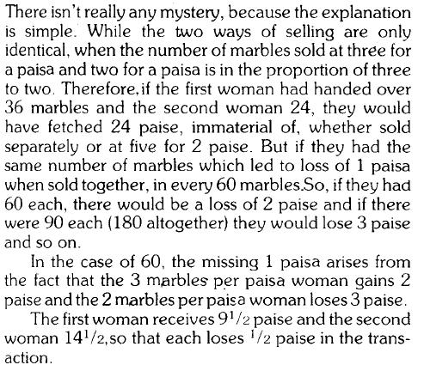

Ans8- 600
Ans9- -40°F
Ans10-
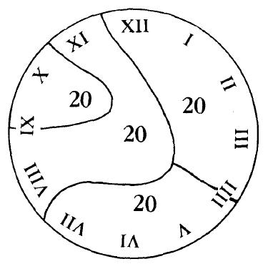

Ans11-
